DIABETES PREDICTION USING MACHINE LEARNING TECHNIQUES

PROJECT REPORT

Submitted By
Lishitha Rapireddy
Department of Computer Science and Engineering (Artificial Intelligence & Machine Learning)
Aditya College of Engineering and Technology
Academic Year: 2026

ABSTRACT
Diabetes is one of the most common chronic diseases affecting millions of people worldwide. Early prediction of diabetes can help in timely diagnosis and treatment. This project focuses on predicting diabetes using Machine Learning techniques. The Pima Indians Diabetes Dataset was used to train and evaluate a Logistic Regression model. Various data analysis and visualization techniques were performed to understand the dataset. The model was evaluated using metrics such as Accuracy, Precision, Recall, F1-Score, and Confusion Matrix. The results demonstrate that Machine Learning can effectively assist in the prediction of diabetes based on medical attributes.

INTRODUCTION
Machine Learning has become an important technology in healthcare for disease prediction and diagnosis. Diabetes is a chronic disease that occurs when blood glucose levels become excessively high. If not detected early, diabetes can lead to severe health complications such as heart disease, kidney failure, and vision problems.
The objective of this project is to develop a Machine Learning model capable of predicting whether a patient is diabetic based on medical measurements such as glucose level, blood pressure, insulin level, BMI, age, and other health indicators.

OBJECTIVE
The main objectives of this project are:
- To analyze the diabetes dataset.
- To perform data visualization and preprocessing.
- To build a Machine Learning classification model.
- To predict diabetes using patient health records.
- To evaluate the model using performance metrics.

TOOLS AND TECHNOLOGIES USED
- Python
- Pandas
- NumPy
- Matplotlib
- Seaborn
- Scikit-Learn
- Visual Studio Code (VS Code)

DATASET DESCRIPTION
The project uses the Pima Indians Diabetes Dataset.

Dataset Information
- Total Records: 768
- Total Features: 8
- Target Variable: Outcome

Attributes
- Pregnancies
- Glucose
- BloodPressure
- SkinThickness
- Insulin
- BMI
- DiabetesPedigreeFunction
- Age
- Outcome
The Outcome column indicates:
- 0 → Non-Diabetic
- 1 → Diabetic

METHODOLOGY

Step 1: Data Collection
The diabetes dataset was downloaded and loaded into Python using the Pandas library.

Step 2: Data Exploration
The dataset was explored using:
- head()
- info()
- describe()
- isnull()
This helped in understanding the dataset structure and checking for missing values.

Step 3: Data Visualization
A count plot generated to visualize the distribution of diabetic and non-diabetic patients.
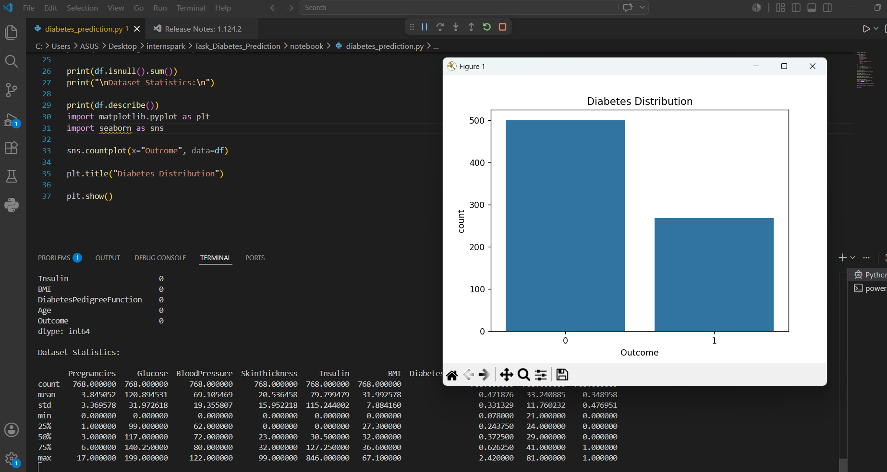
Diabetes Distribution Graph

Step 4: Data Preprocessing
The dataset was divided into:

Features (X)
- Pregnancies
- Glucose
- BloodPressure
- SkinThickness
- Insulin
- BMI
- DiabetesPedigreeFunction
- Age

Target Variable (y)
- Outcome

Step 5: Train-Test Split
The dataset was divided into:
- Training Data: 614 records
- Testing Data: 154 records
The train-test ratio used was 80:20.

Step 6: Model Training
A Logistic Regression model was selected and trained using the training dataset.
The model successfully learned patterns from the patient health data and generated predictions on unseen test data.

Step 7: Model Evaluation
The trained model was evaluated using:
- Accuracy Score
- Precision Score
- Recall Score
- F1 Score
- Confusion Matrix

RESULTS
The Logistic Regression model was successfully trained and tested.

Performance Metrics
Metric | Value
Accuracy | 74.68%
Precision | 63.79%
Recall | 67.27%
F1 Score | 65.49%

Confusion Matrix
Actual / Predicted | Non-Diabetic (0) | Diabetic (1)
Non-Diabetic (0) | 78 | 21
Diabetic (1) | 18 | 37
The confusion matrix shows that the model correctly identified 78 non-diabetic patients and 37 diabetic patients.

Insert Screenshot:
Accuracy, Precision, Recall, F1 Score and Confusion Matrix Output

ADVANTAGES
- Early prediction of diabetes.
- Assists healthcare professionals in decision making.
- Reduces manual analysis effort.
- Improves prediction efficiency.
- Provides quick diagnosis support.

APPLICATIONS
- Healthcare Analytics
- Disease Prediction Systems
- Clinical Decision Support Systems
- Medical Research
- Hospital Management Systems

FUTURE ENHANCEMENTS
- Use larger healthcare datasets.
- Apply advanced Machine Learning algorithms.
- Develop a web-based prediction application.
- Improve prediction accuracy through hyperparameter tuning.
- Integrate real-time patient data.

CONCLUSION
This project successfully demonstrates the use of Machine Learning for diabetes prediction. The Logistic Regression model was trained and evaluated using the Pima Indians Diabetes Dataset. The model achieved an accuracy of 74.68%, indicating its capability to predict diabetes effectively based on patient health parameters.
The project provided practical experience in data analysis, visualization, model training, and performance evaluation. Machine Learning techniques such as Logistic Regression can significantly assist healthcare professionals in identifying diabetic patients at an early stage and improving treatment outcomes.

REFERENCES
- Scikit-Learn Documentation
- Pandas Documentation
- NumPy Documentation
- Matplotlib Documentation
- Seaborn Documentation
- Pima Indians Diabetes Dataset
- Python Official Documentation

